# ThreePhase’s user manual

## Installing the drivers

1. Run windows in “test mode”

Press windows-key + R

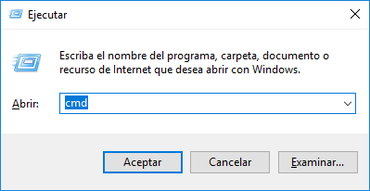

Type in the terminal: dcdedit.exe -set TESTSIGNING ON

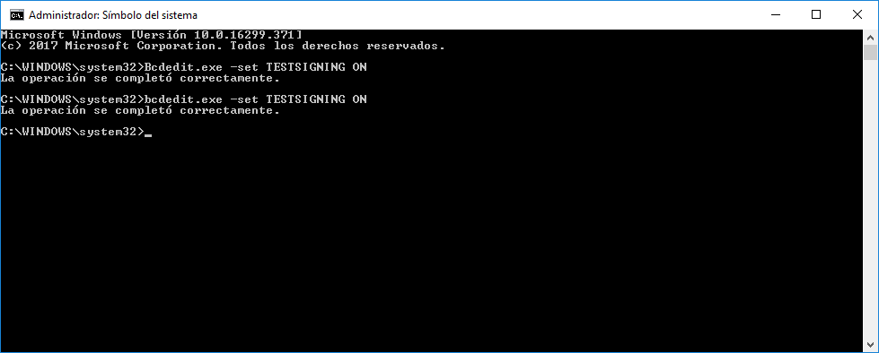

Restart the computer. Now the following should appear in desktop bottom right corner

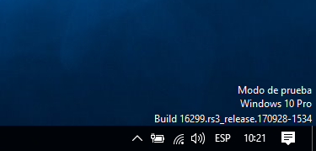

1. Enable the installation of unsigned drivers:

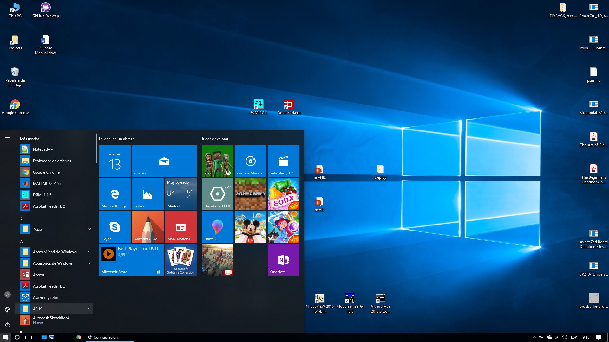

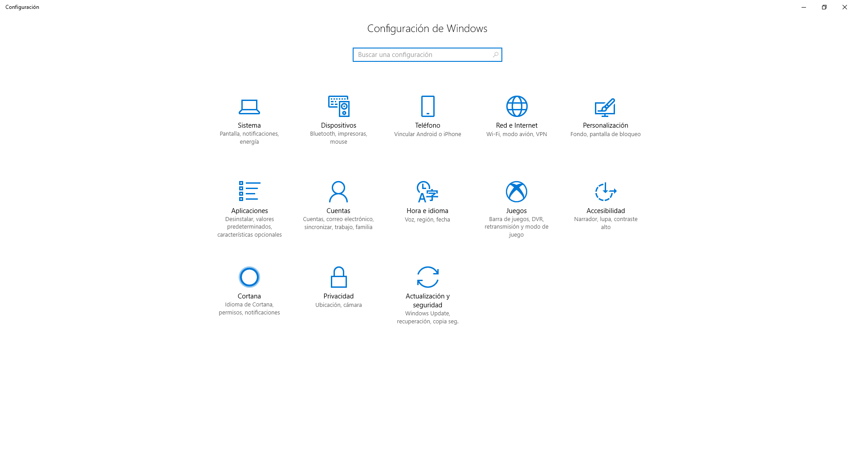

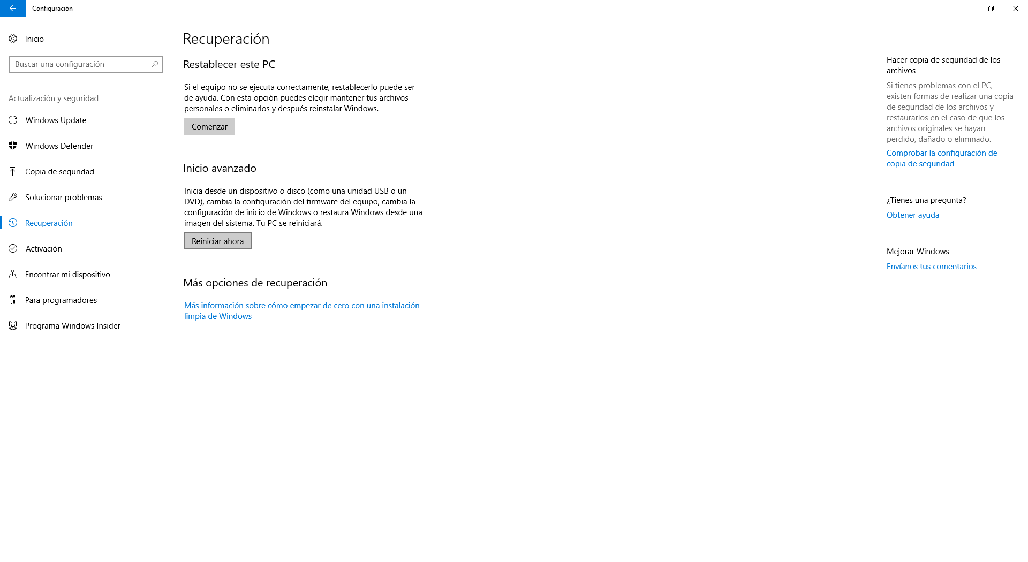

When the computer restarts a Windows boot menu will appear. Select solucionaer problemas/opciones avanzadas/configuración de inicio.

Then the computer Will restart again, and another menu will appear. Press 7 or F7 to allow the installation of unsigned drivers.

1. Install de drivers

When the Zybo board is fully programmed, the device administrator window will show an incorrect USB device.

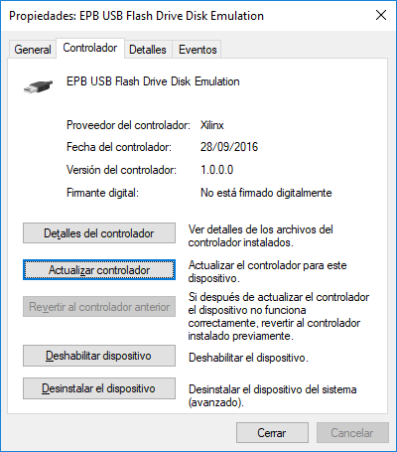

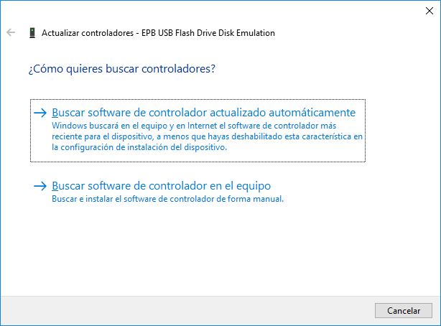

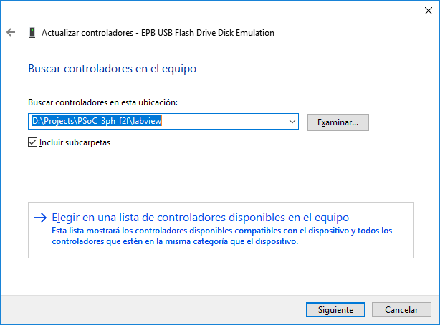

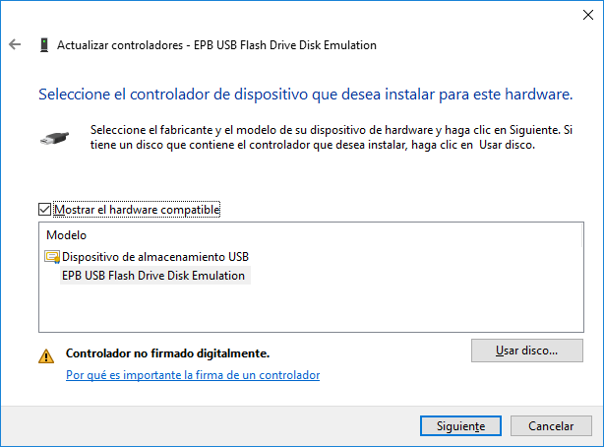

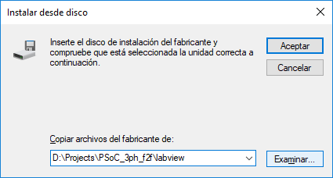

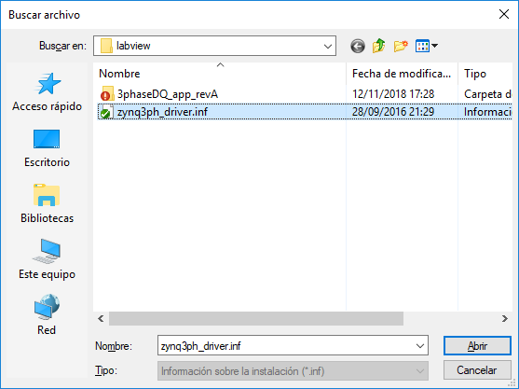

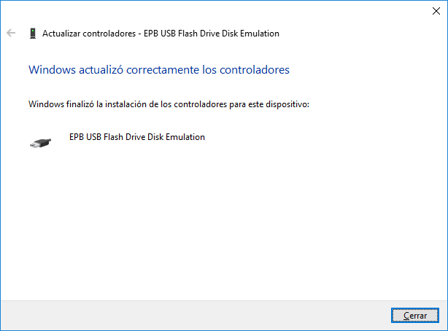

1. The solution of this chapter seen from windows’ device administrator is

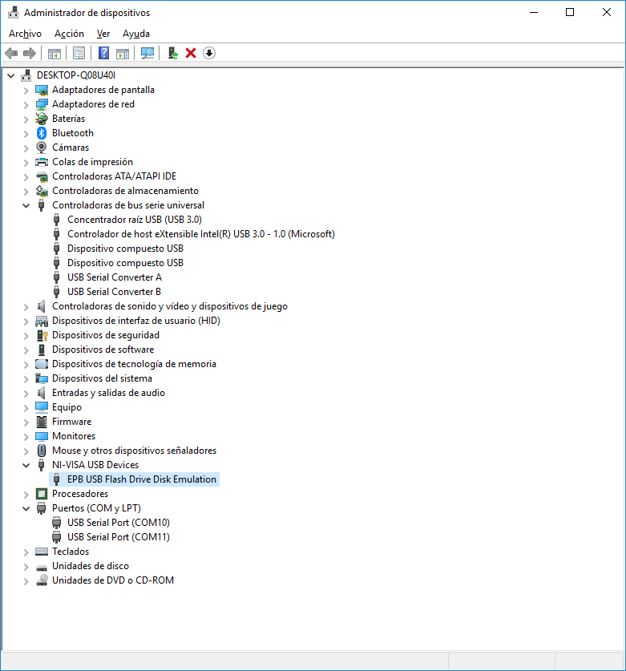

## Connecting the device

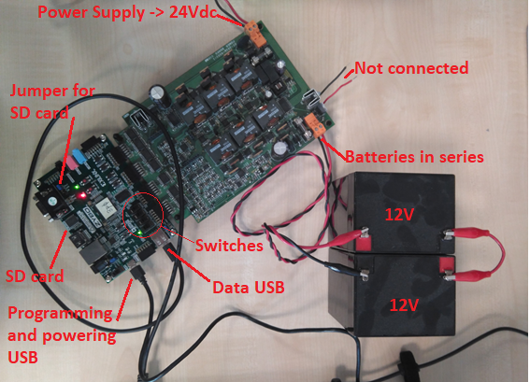

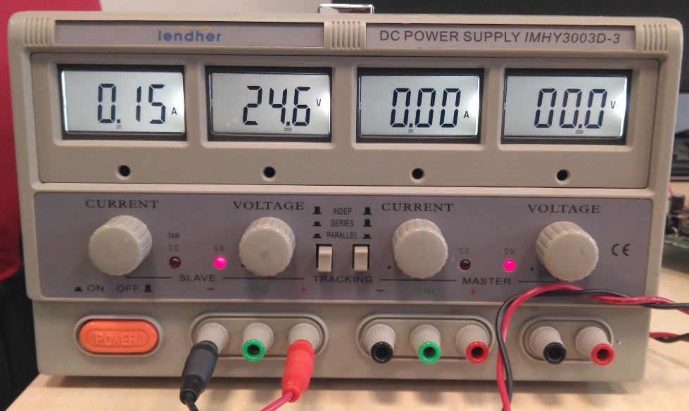

## Programming the device

Zybo board is configured so it auto load the BOOT.ini file included in its DS card. So there is no need to program it manually.

## Running the device

1. Open LabView “Main” application, click on the run button on left top corner and check that is connection stablished

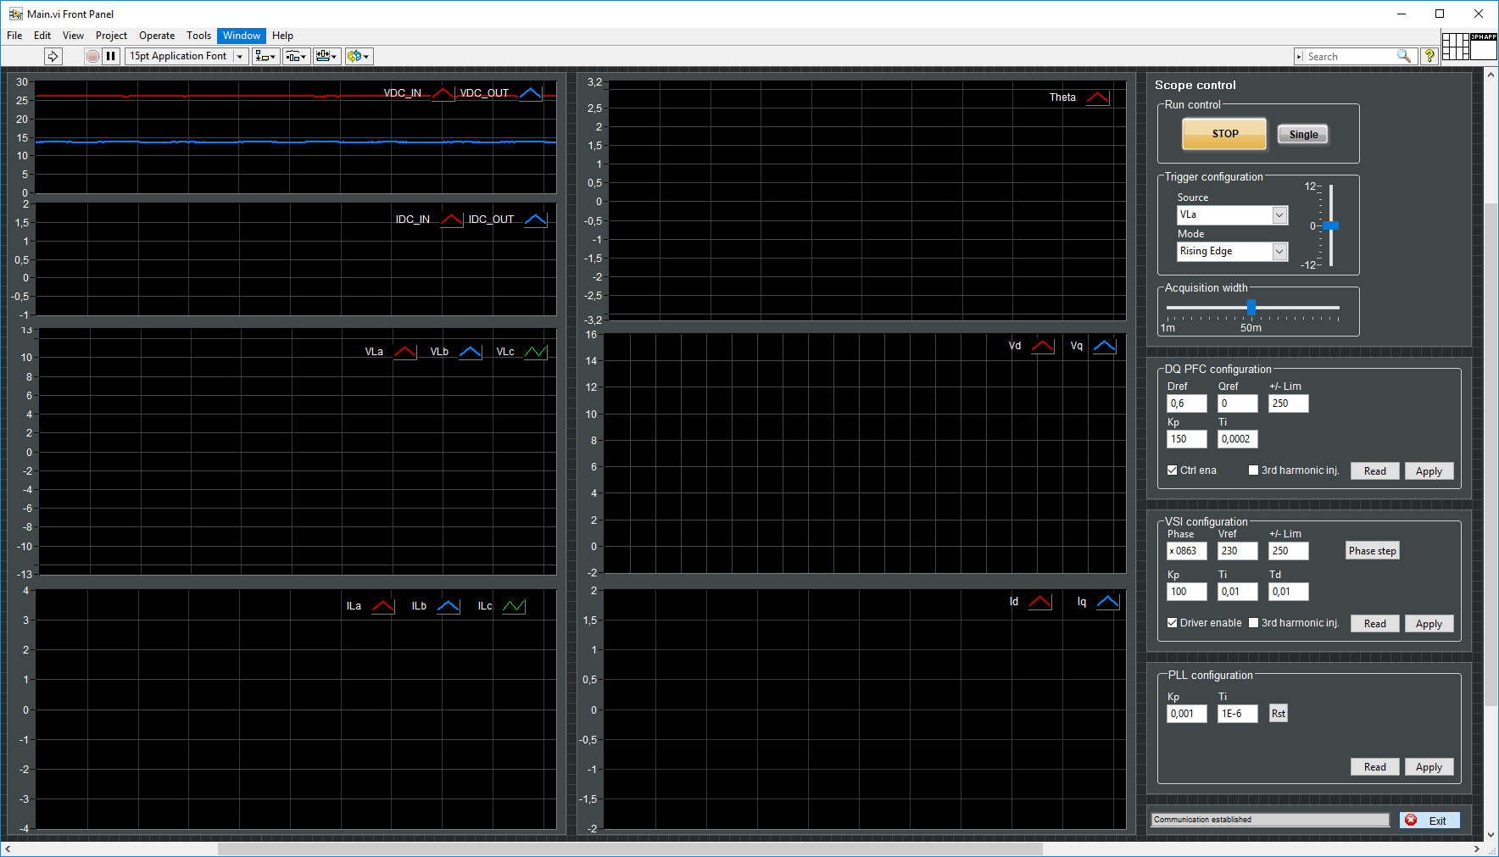

1. Press all the apply buttons from top to bottom
2. Move the ZYBO switchers (up-down-up-down from left to right)

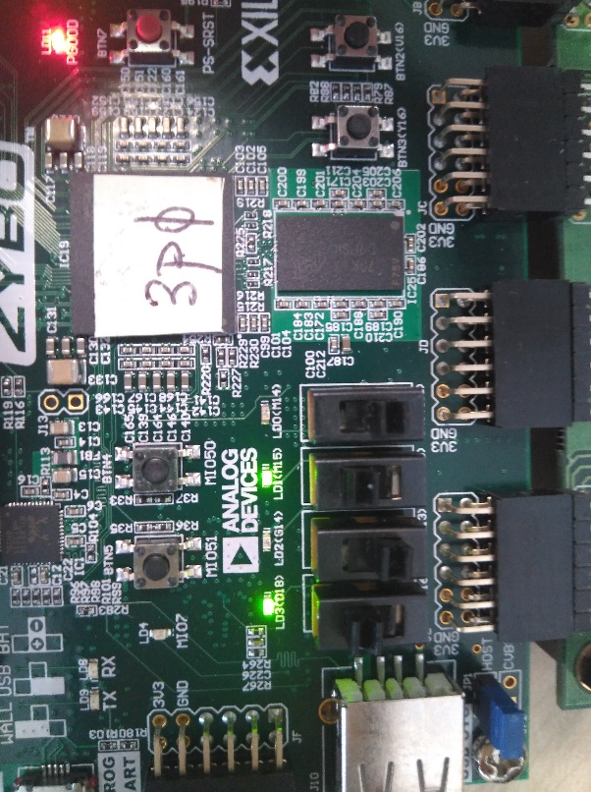

1. Check the waveforms

